Session 03 - Lab Assignment: ARP Poisoning Wei Cui

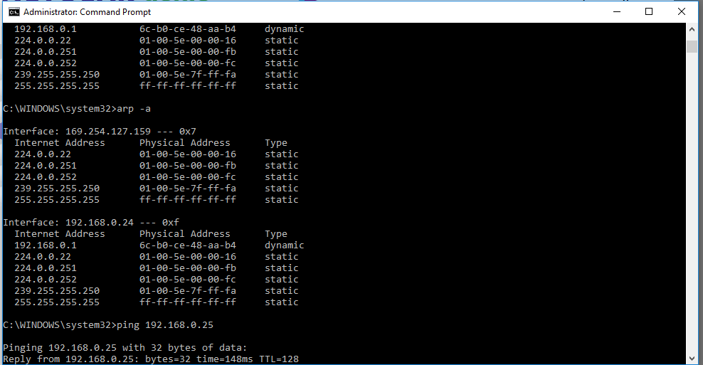

Default Gateway

Fig. 1. Screenshot of ARP Table before the default gateway is deleted

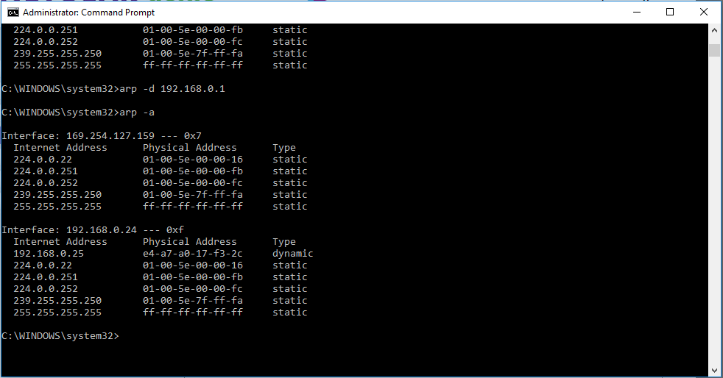

Victim’s IP

Fig. 2. Screenshot of ARP Table after the default gateway is deleted and the victim’s IP is created in the ARP table.